
ARBAMINCH UNIVERSITY INSTITUTION OF TECHNOLOGY

DEPARTMENT OF COMPUTING AND SOFTWARE ENGINEERING
Software Engineering Tools and Practices group assignment
SEC – A
GROUP MEMBERS id
- Kibra G/Tsadkan .......................................... NSR/556/16
- Eyob Weldetensay ...................................... NSR/339/16
- Abeje Goshu ................................................ NSR/017/16
- Ahmed Hussen ............................................ NSR/069/16
- Naol Birhanu ................................................ NSR/753/16
Submitted to: Mr. Yohannis
Submission date:

Table of Contents
- Introduction
1.1 Overview of the Assignment
- Project Description
2.1 Problem Statement
2.2 Objectives of the System
- Methodology and Development Approach
3.1 Software Development Approach
3.2 Development Practices
3.3 Tools Used
- System Understanding & UML Overview
4.1 Introduction to UML
4.2 Importance of UML in Software Development
- Use Case Diagram
5.1 Use Case Diagram Description
5.2 Use Case Diagram
5.3 Explanation of Actors and Use Cases
- Class Diagram
6.1 Class Diagram Description
6.2 Class Diagram
6.3 Explanation of Classes, Attributes, and Methods
- Sequence Diagram
7.1 Sequence Diagram Description
7.2 Sequence Diagram
7.3 Explanation of Interaction Flow
- Activity Diagram
8.1 Activity Diagram Description
8.2 Activity Diagram
8.3 Explanation of Workflow
- Software Tool Details
9.1 Tool Overview
9.2 Features of the Tool
9.3 Advantages of Using the Tool
- Code Generation
10.1 User.java
10.2 LabTechnician.java
10.3 Asset.java
10.4 ICTManager.java
10.5 IssueReport.java

1. Introduction
1.1 Overview of the Assignment
Arba Minch University’s ICT Department manages essential assets such as computers, servers, networking devices, and software licenses. To ensure these resources operate efficiently, an effective asset maintenance system is required to track equipment, schedule maintenance activities, and record technical issues.
Such a system helps reduce downtime, prevent unexpected failures, and ensure timely repairs of ICT assets. It also improves accountability by maintaining accurate asset records and assists staff in managing equipment distribution and returns. In addition, the system supports budgeting and planning by providing clear information on asset status and lifecycle.
Overall, this assignment focuses on modeling an ICT Asset Maintenance System using UML diagrams. The system aims to enhance operational efficiency, improve service quality, and ensure the long-term reliability of the university’s ICT infrastructure.
2. Project Description
2.1 Problem Statement
Arba Minch University’s ICT Department manages a large number of assets, including computers, servers, networking devices, and software licenses. Currently, managing these assets manually or using fragmented systems makes it difficult to track asset status, maintenance history, and reported issues. As a result, equipment failures may go unnoticed, maintenance activities may be delayed, and accurate records may not be available when needed.
The lack of a centralized asset maintenance system can lead to increased downtime, inefficient use of resources, poor accountability, and difficulty in planning budgets for repairs and replacements. Without proper documentation and monitoring, it is also challenging to ensure timely equipment distribution, returns, and lifecycle management. Therefore, there is a need for a structured system that can effectively manage ICT assets and their maintenance activities.
2.2 Objectives of the System
The main objective of the ICT Asset Maintenance System is to provide an efficient and organized way to manage and maintain ICT assets within the university. The specific objectives of the system are:
- To maintain accurate records of all ICT assets.
- To track asset status, location, and usage.
- To schedule and monitor maintenance activities.
- To record and manage reported technical issues.
- To reduce system downtime and prevent unexpected failures.
- To improve accountability and transparency in asset management.
- To support planning and budgeting through asset lifecycle data.
3. Methodology and Development Approach
3.1 Software Development Approach
For the development of the ICT Asset Maintenance System, our group selected the Object-Oriented Analysis and Design (OOAD) approach tailored within an Iterative Development Model.
- Rationale: We chose OOAD because the system relies heavily on distinct entities (Assets, Users, Reports) that interact with each other. This approach allows us to map real-world objects (like a "Computer" or a "Technician") directly into software classes.
- Iterative Process: We divided the project into phases: first understanding requirements, then modeling the structure (Class diagrams), followed by behavior modeling (Sequence diagrams), and finally code generation. This allowed us to refine our diagrams before writing code.
3.2 Development Practices
To ensure successful completion, the group applied the following practices:
- Requirement Engineering: We started by identifying actors and use cases to understand the system boundaries.
- Visual Modeling: We used UML standards to visualize the system before implementation to reduce logical errors.
- Collaborative Design: The group worked together to synchronize the understanding of the system, ensuring that the structural models (Class diagram) aligned with the behavioral models (Sequence diagram).
3.3 Tools Used
- Modeling Software: StarUML and Draw.io were used to create the UML diagrams. StarUML was specifically selected for its ability to adhere to strict UML 2.0 standards and support code generation.
- Programming Language: Java was selected for the implementation because of its strong Object-Oriented features (Inheritance, Polymorphism) which align with our Class Diagram.
- Documentation: Microsoft Word was used for compiling the final report.

4. System Understanding & UML Overview
4.1 Introduction to UML
Unified Modeling Language (UML) is a standardized graphical language used to visualize, design, and document software systems. It provides a set of diagrams that represent different aspects of a system, such as structure, behavior, and interactions between components. UML is widely used in software engineering to model systems before they are developed, making complex systems easier to understand and communicate.
UML diagrams help developers, designers, and stakeholders clearly understand system requirements and functionality. By using symbols and notations, UML offers a common language that improves communication among team members involved in software development.
4.2 Importance of UML in Software Development
UML plays an important role in software development by helping teams plan and analyze systems effectively before implementation. It allows developers to identify system requirements, define system architecture, and detect potential design issues at an early stage.
Using UML improves documentation quality and makes systems easier to maintain and modify. It also supports better collaboration among team members by providing a clear visual representation of system behavior and structure. Overall, UML enhances software quality, reduces development risks, and ensures that the final system meets user requirements.
5. Use Case Diagram
5.1 Use Case Diagram Description
The Use Case Diagram visualizes the functional requirements of the AMU ICT Lab Assets and Maintenance Management System. It defines the system's boundary and illustrates the interactions between the system and external entities (actors). The diagram identifies four primary actors: Student/Staff, ICT Manager, Lab Technician, and System Administrator.
The diagram showcases how these actors interact with various functionalities (use cases) such as asset registration, maintenance tracking, reporting, and user management. It also highlights dependencies between use cases, specifically using the <<include>> relationship to indicate that authentication (Login) is a mandatory step for critical administrative and reporting functions.

5.2 Use Case Diagram
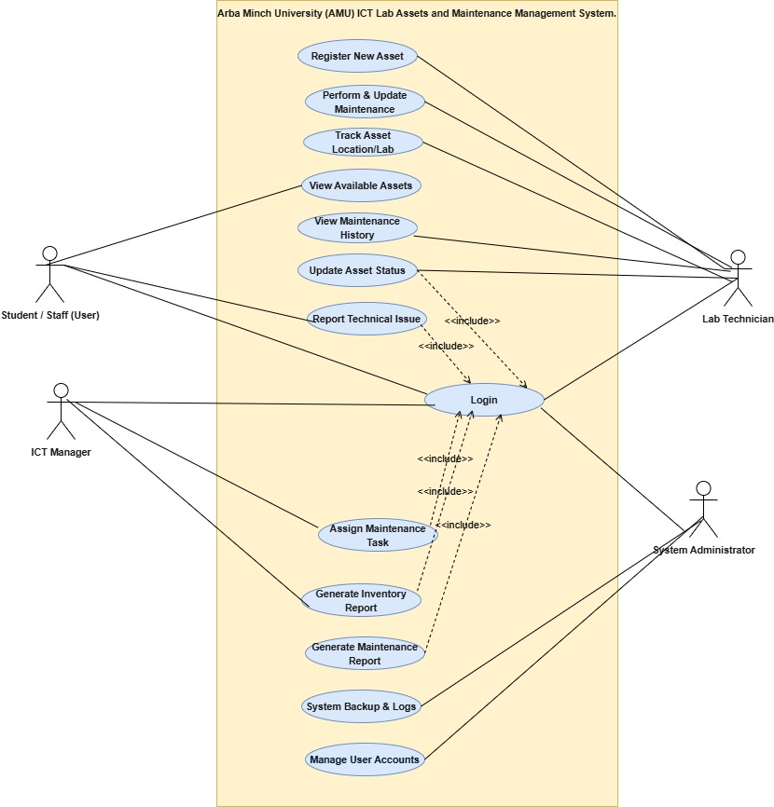
5.3 Explanation of Actors and Use Cases
5.3.1 Actors
- Student / Staff (User): Represents the general end-users of the ICT lab. They have limited access, primarily focused on viewing asset availability and reporting faults.
- ICT Manager: A supervisory role responsible for overseeing the maintenance operations, assigning tasks to technicians, and generating administrative reports to monitor lab inventory and health.
- Lab Technician: The operational role responsible for the physical management of assets. They handle the registration of new hardware, perform maintenance, update status, and track where assets are located.
- System Administrator: The technical administrator responsible for the system's health, data integrity (backups), and security management (creating and managing user accounts).
5.3.2 Use Cases
Core System Functions:
- Login: A security use case that authenticates users. Several critical use cases (such as updating status or generating reports) explicitly <<include>> this use case.
Asset & Maintenance Management:
- Register New Asset: Allows the Lab Technician to enter details of new equipment into the system database.
- Perform & Update Maintenance: Used by Lab Technicians to log details of repairs performed on specific assets.
- Track Asset Location/Lab: Allows the Lab Technician to record and update the physical location of an asset.
- Update Asset Status: Allows the Lab Technician to change the condition of an item.
- Report Technical Issue: Allows Students or Staff to submit a ticket regarding faulty equipment.
- Assign Maintenance Task: Allows the ICT Manager to delegate specific repair jobs to Lab Technicians.
Information & Reporting:
- View Available Assets: Accessible by Students/Staff to see a list of equipment currently available.
- Generate Inventory/Maintenance Report: Allows the ICT Manager to create summary documents.
System Administration:
- System Backup & Logs: Allows the System Administrator to save database backups.
- Manage User Accounts: Allows the System Administrator to create, update, or delete user profiles.
6. Class Diagram
6.1 Class Diagram Description
The Class Diagram illustrates the static structure of the system, defining the objects (classes), their attributes, methods, and the relationships between them. It employs Generalization (Inheritance) to derive specific user roles (Student/Staff, Technician, Manager, Admin) from a central User class. It also utilizes Association to show how users interact with system entities (e.g., submitting reports or performing tasks) and Aggregation to represent the relationship between Labs and Assets (a Lab contains Assets).
6.2 Class Diagram
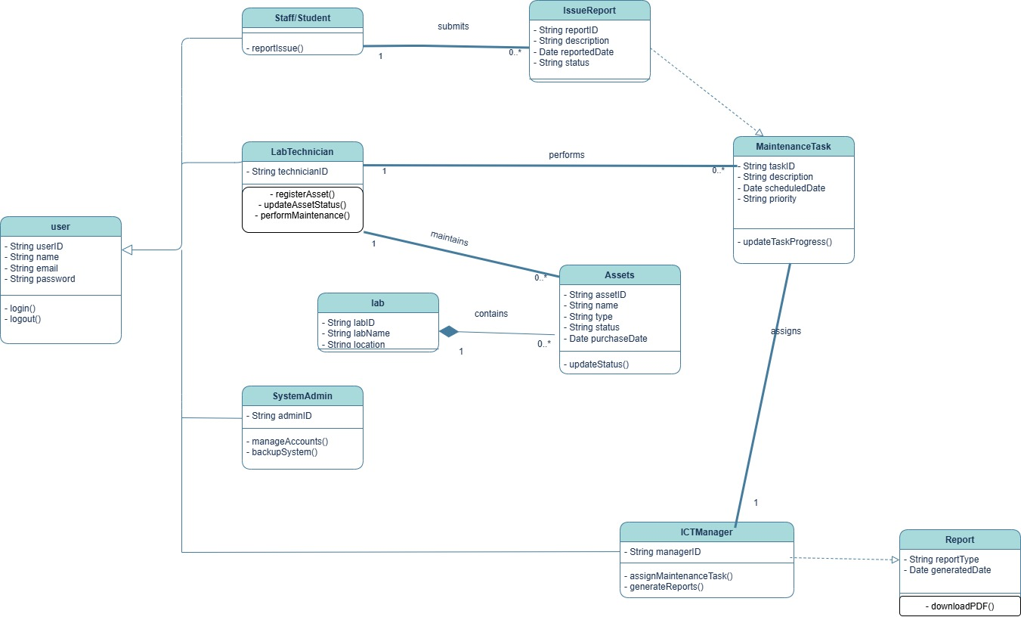

6.3 Explanation of Classes, Attributes, and Methods
6.3.1 User Classes (Inheritance Structure)
The system uses a parent User class to hold common data, which is inherited by four specific actors.
- User (Superclass):
  - Attributes: userID, name, email, password.
  - Methods: login(), logout().
- Staff/Student:
  - Methods: reportIssue().
- Lab Technician:
  - Attributes: technicianID.
  - Methods: registerAsset(), updateAssetStatus(), performMaintenance().
- ICTManager:
  - Attributes: managerID.
  - Methods: assignMaintenanceTask(), generateReports().
- SystemAdmin:
  - Attributes: adminID.
  - Methods: manageAccounts(), backupSystem().
6.3.2 System Entity Classes
- Assets: Represents the physical hardware equipment.
  - Attributes: assetID, name, type, status, purchaseDate.
  - Methods: updateStatus().
- Lab: Represents the physical room where assets are located.
  - Relationship: Aggregation with Assets (A Lab contains multiple Assets).
- IssueReport: A ticket submitted by a Staff/Student regarding a fault.
  - Attributes: reportID, description, reportedDate, status.
- MaintenanceTask: A work order generated from an issue report.
  - Attributes: taskID, description, scheduledDate, priority.
  - Methods: updateTaskProgress().
7. Sequence Diagram
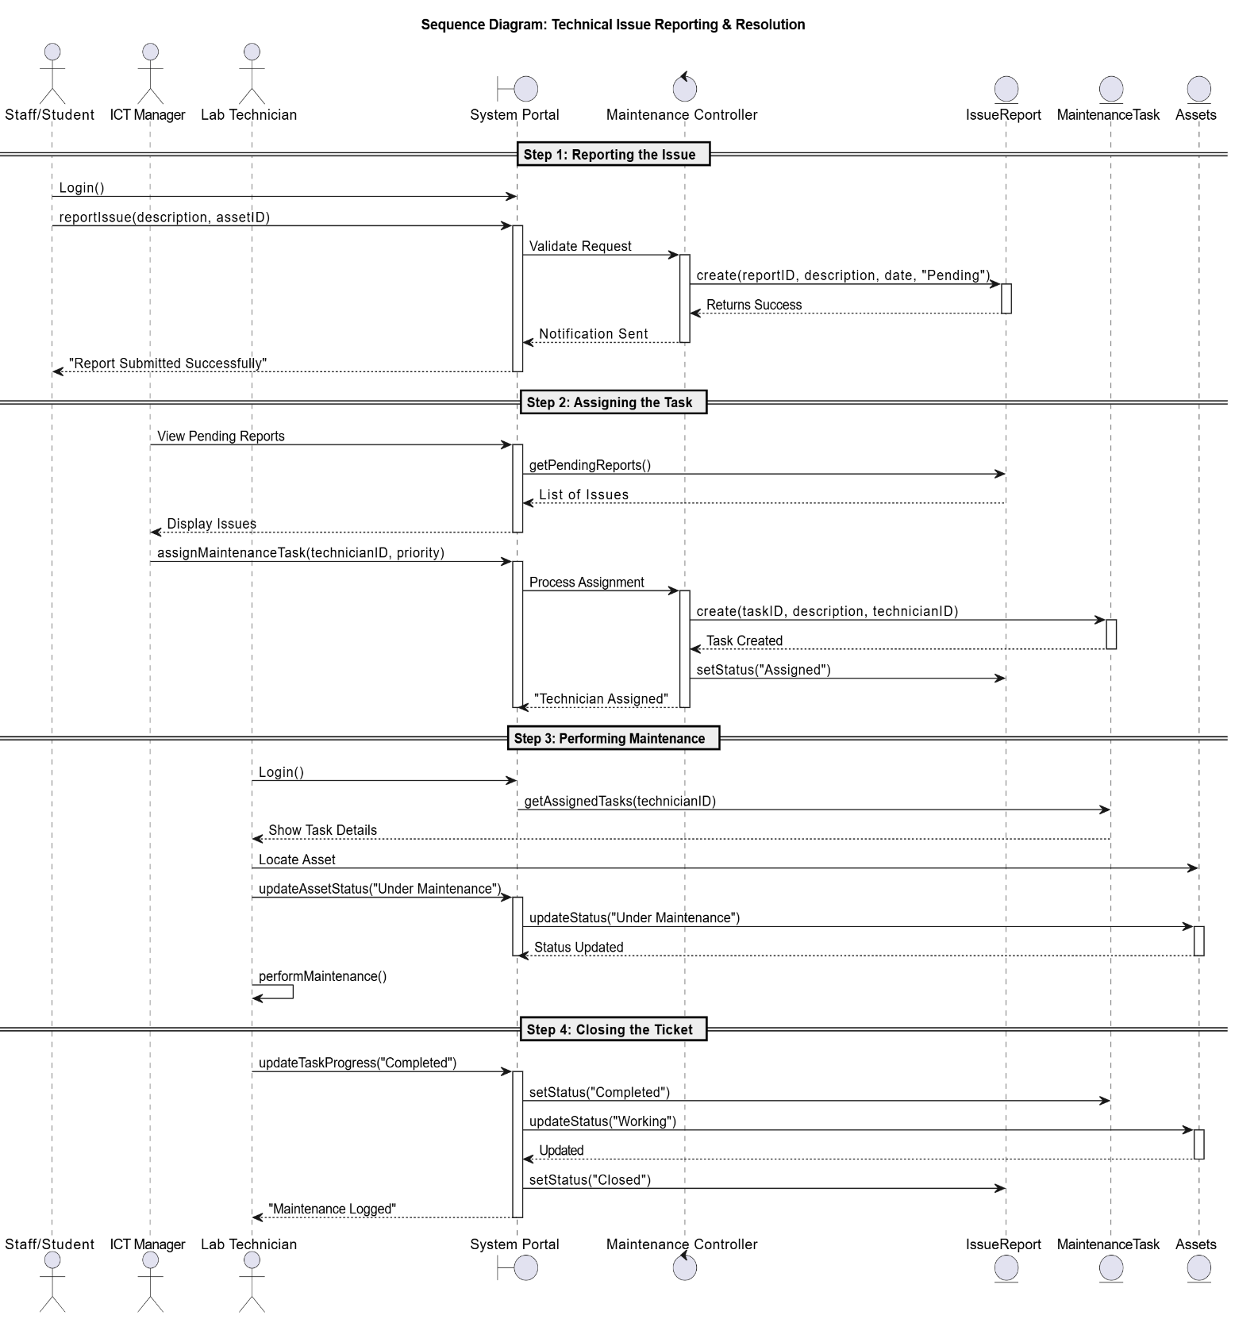

7.3 Explanation of Interaction Flow
The interaction is structured into four distinct logical steps:
- Reporting the Issue: The Staff/Student logs in and submits a reportIssue() request. The Controller validates the input and creates a new IssueReport entity with a status of "Pending".
- Assigning the Task: The ICT Manager views pending reports and assigns a technician. The system creates a MaintenanceTask and updates the report status to "Assigned".
- Performing Maintenance: The Lab Technician retrieves tasks, updates the Asset status to "Under Maintenance" (preventing usage by others), and performs repairs.
- Closing the Ticket: Once repairs are done, the Technician updates the task to "Completed". The system automatically updates the Asset status back to "Working" and closes the Issue Report.
8. Activity Diagram
8.1 Activity Diagram Description
The Activity Diagram illustrates the operational workflow for adding new equipment to the AMU ICT Lab Assets and Maintenance Management System. It visually maps the sequence of actions performed by the Lab Technician, starting from system login to the successful storage of asset data.
Key logic flows included in this diagram are:
- Data Entry: Capturing essential asset attributes.
- Location Validation: A decision process to check if a Lab exists, with an option to create a new Lab if it doesn't.
- Iterative Registration: A loop structure that allows the technician to register multiple assets consecutively.

8.2 Activity Diagram
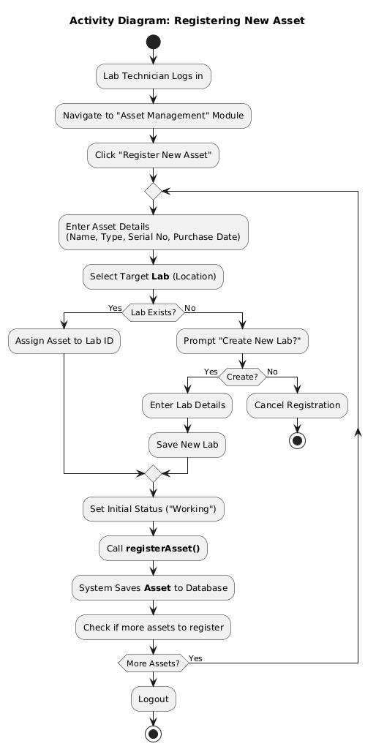

8.3 Explanation of Workflow
- Initialization: The Lab Technician logs in and selects "Register New Asset".
- Asset Details: The technician enters hardware details (Name, Serial Number) and selects a target Lab.
- Lab Validation (Decision Node): The system checks if the Lab exists. If not, the system prompts to create a new Lab.
- Finalizing Registration: The system sets the status to "Working" and saves the Asset to the database.
- Iteration (Loop Node): The system asks "More Assets?". If yes, it loops back to data entry; if no, the process ends.
9. Software Tool Details
9.1 Tool Overview
To design the architectural blueprints for the Arba Minch University ICT Lab Assets and Maintenance Management System, specific Computer-Aided Software Engineering (CASE) tools were utilized.
The following platforms were identified and utilized:
- Draw.io (diagrams.net): A versatile, web-based diagramming software used for creating initial sketches and flowcharts.
- StarUML: A sophisticated modeler used for creating the detailed Class and Sequence diagrams where strict syntax and code generation capabilities were required.
- Wondershare EdrawMax: Used for creating high-level architectural views and presentation-ready Use Case diagrams.
9.2 Features of the Tools
- Drag-and-Drop Interface: Intuitive sidebars with pre-defined UML symbols.
- UML Standard Compliance: Supports comprehensive sets of standard diagrams including Use Case and Class diagrams.
- Vector-Based Editing: Diagrams remain sharp and scalable for documentation.
9.3 Advantages of Using These Tools
- Efficiency: Pre-built templates allowed for rapid prototyping.
- Accessibility: Web-based tools facilitated remote work.
- Professional Documentation: Ability to export in PNG/PDF ensured high-quality report presentation.
10. Code Generation
Based on the Class Diagram designed in Section 6, the following initial Java code skeletons were generated. This code represents the structural aspect of the system (Classes, Attributes, and Method signatures).
10.1 User.java (Base Class)
public class User {
protected String userID;
protected String name;
protected String email;
protected String password;

public boolean login(String email, String password) {
// Logic to verify credentials
return true;
}
public void logout() {
// Logic to end session
}
}
10.2 LabTechnician.java (Inherits from User)

public class LabTechnician extends User {
private String technicianID;

public void registerAsset(Asset asset) {
// Logic to add new asset to database
}

public void updateAssetStatus(String assetID, String status) {
// Logic to update status
}

public void performMaintenance(String taskID) {
// Logic to log maintenance work
}
}
10.3 Asset.java

import java.util.Date;

public class Asset {
private String assetID;
private String name;
private String type;
private String status; // e.g., Working, Broken
private Date purchaseDate;

public void updateStatus(String newStatus) {
this.status = newStatus;
}

// Getters and Setters
public String getStatus() { return status; }
}
10.4 ICTManager.java

public class ICTManager extends User {
private String managerID;

public void assignMaintenanceTask(String technicianID, String reportID) {
// Logic to assign a task
}

public void generateReports(String reportType) {
// Logic to generate PDF report
}
}
10.5 IssueReport.java

import java.util.Date;

public class IssueReport {
private String reportID;
private String description;
private Date reportedDate;
private String status; // Pending, Assigned, Closed

public IssueReport(String desc) {
this.description = desc;
this.reportedDate = new Date();
this.status = "Pending";
}
}
11. References
- Sommerville, I. (2015). Software Engineering (10th ed.). Pearson Education.
- Pressman, R. S., & Maxim, B. R. (2014). Software Engineering: A Practitioner’s Approach (8th ed.). McGraw-Hill Education.
- Booch, G., Rumbaugh, J., & Jacobson, I. (2005). The Unified Modeling Language User Guide (2nd ed.). Addison-Wesley Professional.
- Arba Minch University ICT Directorate. (2023). ICT Lab Asset Management Policies and Guidelines. (Internal Document).
github repo
https://github.com/naol-e/AMU-ICT-Asset-Maintenance-System.git

